PRACTICAL - 04
Aim:
To write a Python program to calculate the factorial of a number using both Iterative and Recursive methods, and analyze their execution time.
Theory:
The factorial of a non-negative integer n, denoted as n!, is the product of all positive integers from 1 to n (with 0! defined as 1). It can be calculated in two ways:
- Iterative Method: Uses a loop (for/while) to multiply numbers from 1 to n sequentially. It uses a constant amount of extra memory (O(1) space) and generally runs faster since it avoids function call overhead. Its time complexity is O(n).
- Recursive Method: The function calls itself with a smaller value (n-1) until it reaches the base case (n=0 or n=1), then multiplies the results while returning back up the call stack. Its time complexity is also O(n), but it uses O(n) additional space for the call stack, and repeated function calls introduce overhead, making it comparatively slower than the iterative approach for larger values of n.
Comparing both methods highlights a common trade-off in programming: recursion often gives cleaner, more readable code, while iteration is generally more time- and memory-efficient.
Algorithm:
- Input the number n whose factorial is to be calculated.
- Iterative Method: Initialize result = 1; run a loop from i = 1 to n, multiplying result = result * i at each step.
- Record the start time before the iterative method begins and the end time after it completes; calculate the time taken.
- Recursive Method: Define a function factorial(n) such that if n == 0 or n == 1, return 1 (base case); otherwise return n * factorial(n-1).
- Record the start time before the recursive method begins and the end time after it completes; calculate the time taken.
- Display the factorial obtained from both methods.
- Display and compare the time taken by both methods.

Program Code:
def factorial_recursive(n):
if n == 0 or n == 1: # base case
return 1
return n * factorial_recursive(n - 1)

# Demo
if __name__ == "__main__":
num = 33
print(f"Iterative Factorial of {num}: {factorial_iterative(num)}")
print(f"Recursive Factorial of {num}: {factorial_recursive(num)}")

Output:
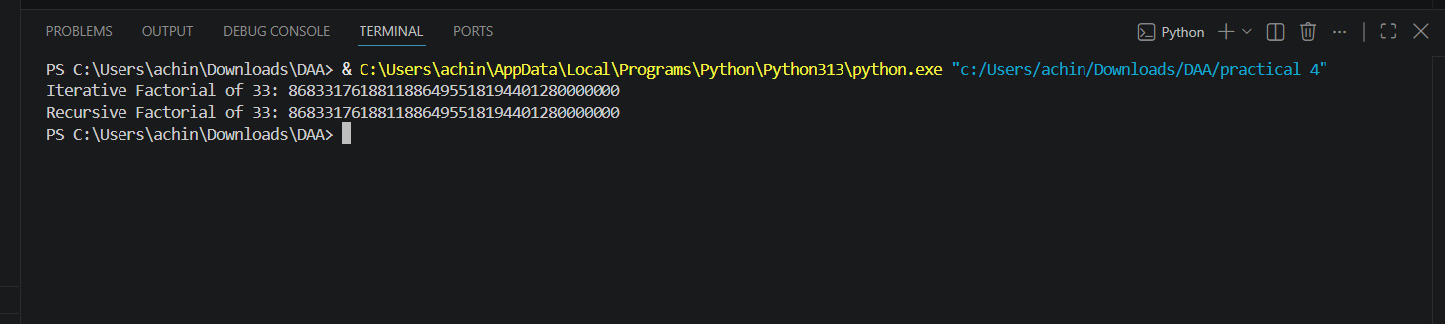

Result:
The program successfully calculates the factorial of a number using both Iterative and Recursive methods, and the execution time of each is measured using System.nanoTime(). It is observed that the Iterative method generally performs faster than the Recursive method, as recursion incurs additional overhead due to repeated function calls and stack usage.

